The Constitution of the United States requires that a census be conducted every ten years. This count determines how many representatives each state will have in Congress. The count also gives us a look at trends in the country, such as changes in groups and the population as a whole. In this activity, you will use data to create graphs showing changes in the population of South Carolina in the last half of the 20th century.

Instructions: Use the information from the link below to find information to create graphs.

United States Census Data: South Carolina start on page 2

Part I: Finding the Facts
Take a moment to see how the data are organized. You will notice years at the top of columns, with each row standing for the national, state, or county population. The most recent data are at the top of the webpage.

- What was the population of South Carolina in 1990? ______________

- What was the population of South Carolina in 1940? ______________

- By how much did South Carolina’s population change between 1940 and 1990?
__________________________________________________________________

- Let’s see what that looks like as a percentage increase (Hint: use this equation:
((population in 1990 – population in 1940) ÷ population in 1940) x 100 = _________

- Use the same process to calculate the percent increase in population of the United States during the same period and record that information. ______________

- In a sentence, compare the population trend of the U.S. with that of South Carolina during this time period.
__________________________________________________________________
Year | Population
1940
1950
1960
1970
1980
1990

- Complete the table with population data about South Carolina using information from the website.

Part II: Creating a Graph
These directions will help you create a graph using Microsoft Excel. If you have another spreadsheet program, the steps will be similar.

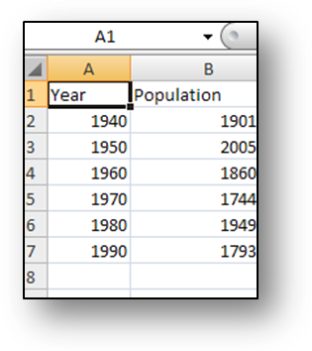
- Launch your spreadsheet program, Microsoft Excel, and make sure that you are on a new, blank spreadsheet.
- In cell A1, type “Year.”
- In cell B1, type “Population.”
- Using the information on the website, enter the population for South Carolina for each decade from 1940 to 1990.
- Now, have the computer take these data and make a graph. Click on cell B1 and without releasing the mouse, drag down to cell B7. This should highlight all of your population data.
- Click Insert tab and from the Charts group, choose Line. Choose one of the line graph types.
- Click the area of the horizontal axis labels (which now simply say 1, 2, 3, etc.) to select it. Then, right-click it and choose Select Data.
- In the window that opens, click the Edit button under Horizontal (Category) Axis Labels.
- Now, click cell A2, hold the mouse button down, and drag down to cell A7 to select your list of years. Click OK.
- Click OK.
- Edit your title, as needed, by double-clicking on the title and adding a more complete title.

Click the graph to select it, and then use your print command to print your graph. Be sure to preview the graph before printing to make sure that you are printing the correct part of your work.

Part III: Use the directions that you just followed to create another graph. This time, create a graph for the county where you live in South Carolina. Look on page 140 of the online book for information.
Print a copy of the completed graph and staple it to this activity sheet. Write a short summary of the trends that you notice on the graphs. Does the graph for your county follow a pattern similar to that of the state? Are their differences? Explain what you notice.

